0.1 | 2025/10/15 | initial release |  |  |  |  | pnb
Rev. | Issued date | Description |  |  |  |  | Made by
 | pnb plants & bytes GmbH
Project:
 | DISC DEXPI Continuation Project
Document title:  P&ID Validation Method |  |  |  |  |  |  |  |  | Rev:  0.1 |  | Page:  1 of 6

Table of Contents
1 Abstract 3
2 Formal Verification 4
2.1 XML Compliance 4
2.2 DEXPI Schema Compliance 5
2.3 DEXPI Specification Compliance 5
2.4 DISC Profile Compliance 6
3 Content Validation 6
4 Graphical Validation 6
5 Overall Scorecard 6

Abstract
The DEXPI initiative, launched in 2011, aims to establish a common data exchange standard for the process industry. Historically, most DEXPI-related work is conducted within standalone projects, with limited focus on transferring DEXPI P&ID files between different CAD vendors.
Prior to the current DISC DEXPI Continuation Project, the NOAKA DEXPI Project documents most of the requirements for DISC partners to implement DEXPI in a standardized way and addressed several gaps between the DISC requirements and the existing DEXPI specification.
This document covers one of these gaps, i.e., a method for the validation of DISC DEXPI P&ID files. The method aims to evaluate the correctness of DISC DEXPI P&ID files produced by CAE tools and thus to ensure correct data exchange via these files.

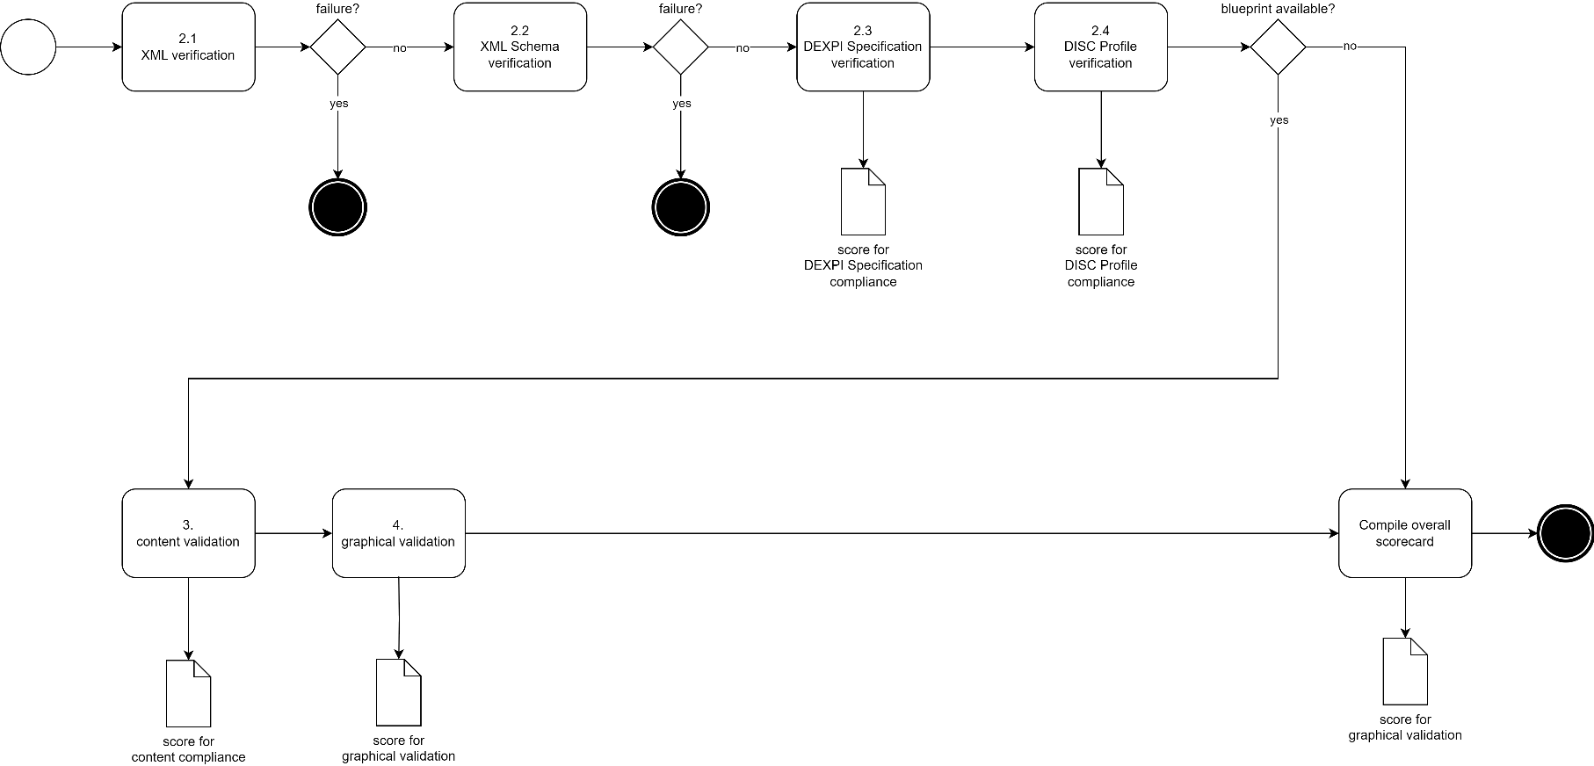

Formal Verification
Verification aims at checking the formal correctness of a DISC DEXPI P&ID file. It happens on several levels.

XML Compliance
Correct (“well-formed”) XML is indispensable for any further analysis of a DISC DEXPI P&ID file because XML libraries will typically refuse to load incorrect files (and thus make any further verification impossible). Vice-versa, XML verification can be fully automated by any compliant XML library.
Result: passed (continue) or not passed (terminate)
Underlying specification:
- Extensible Markup Language (XML) 1.0 (Fifth Edition), W3C Recommendation 26 November 2008 (https://www.w3.org/TR/REC-xml/)

DEXPI Schema Compliance
Since DEXPI 2.0, a new data format called DEXPI XML is used for the exchange of DEXPI P&IDs. A corresponding XML Schema formalizes the structure of a valid DEXPI XML file. Validation of a file with respect to the XML Schema can be fully automated with a suitable XML library.
Result: passed (continue) or not passed (terminate)
Underlying specifications:
- XML Schema (https://www.w3.org/XML/Schema)
- DEXPI XML Schema (https://dexpi.org/specifications; direct link to schema (2025-10-13): https://dexpi.gitlab.io/-/Specification/-/jobs/11676485644/artifacts/src/.build/html/html/_static/DEXPI_XML_Schema.xsd)

DEXPI Specification Compliance
The DEXPI Specification 2.0 defines constraints on DEXPI XML that are not covered by the DEXPI XML Schema. In particular, these constraints ensure the conformance of P&ID data with DEXPI Plant, an information model for P&IDs. For an automated check of these constraints, specific software is required.
Result:
$$score = 100-\frac{100* number of violated constraints}{number ofobjects+number of data values+number of links}$$
- number of links is the number of correct property values (composition, reference, data).
- A score smaller than 0 is capped, i.e., 0 ≤ score ≤ 100.
- score is rounded to the nearest integer.
Underlying specification:
- DEXPI Specification 2.0 or later (https://dexpi.org/specifications)

DISC Profile Compliance
Beyond extending the DEXPI Plant information model, the DISC DEXPI Profile imposes additional constraints on a correct P&ID. For example, the profile prescribes the symbols to be used for certain conceptual objects, and it defines certain attributes as mandatory.
Result:
$$score = 100-\frac{100* number of violated constraints}{number ofobjects+number of data values+number of links}$$
- number of links is the number of correct property values (composition, reference, data).
- A score smaller than 0 is capped, i.e., 0 ≤ score ≤ 100.
- score is rounded to the nearest integer.
Underlying specification:
- DISC DEXPI Pilot Transfer Requirements and other documents created in the project
- DISC DEXPI Profile

Content Validation
to be written; see DEXPI File Comparison for Test Automation.pptx for an overview

Graphical Validation

Overall Scorecard

During the development of DEXPI XML Schema on behalf of DEXPI e.V., pnb has checked if conventional XML libraries are able to handle the schema correctly. For these libraries no issues were detected: - .NET implementation by Microsoft (namespace System.Xml.Schema). VERSION? - Python: lxml version 5.4.0. lxml uses the C library libxml2, so other language bindings of libxml2 may be good candidates for other languages than Python. - Java: javax.xml.validation package. VERSION?
In case of DISC DEXPI, an extension of the DEXPI Plant information model is used that accounts for specific requirements of the stakeholders within the DISC DEXPI Continuation Project. This extension is formalized in the DISC Profile. Profiles are not yet an official feature of DEXPI 2.0, but their impact on conformance checking of data w.r.t. an information model is straightforward.

